Operating Systems

Subject course code: CSE 316
Report on
Assignment Simulation
Based


Student Name: Pulikonda Sai Kiran
Reg no: 11702940
Section: EE029
Roll no: A26
Email: Saikiranpulikonda@gmail.com
Phone no: 8096060756
GitHub Link: https://github.com/Saikiran2122/Shortest-Job-First-Scheduling-Preemptive-.git

Question no 4:

Consider the scenario, there are 3 student processes and 1 teacher process. Students are supposed to do their assignments and they need 3 things for that-pen, paper and question paper. The teacher has an infinite supply of all the three things. One student has pen, another has paper and another has question paper. The teacher places two things on a shared table and the student having the third complementary thing makes the assignment and tells the teacher on completion. The teacher then places another two things out of the three and again the student having the third thing makes the assignment and tells the teacher on completion. This cycle continues. WAP to synchronise the teacher and the students.

Code (C#):
using System;
using System.Collections.Generic;
using System.Diagnostics;
using System.Linq;
namespace Mahesh_Os_Project
{
public class Question2
{
public class Student
{
public string Name;
public bool PaperAvial, PenAvial, QuestionAvail, Done;
public short CompletionRank, Waiting;
}
public class Teacher
{
public string Name;

public List<Student> Students = new List<Student>();
}
public static short Rank;
public static void Print(Teacher Invigilator)
{
Console.Clear();

Console.WriteLine($"Teacher Name : {Invigilator.Name}");

Console.WriteLine("Students Details : ");

foreach (var item in Invigilator.Students)
{
Console.WriteLine("\n\nName " + item.Name);
Console.WriteLine("Waiting Time : "+item.Waiting);
Console.WriteLine("Completion : " + item.CompletionRank);
}
}
public static void Run()
{
Teacher Invigilator = new Teacher();

Console.Write("Invigilator Name :");
Invigilator.Name = Console.ReadLine();

Console.Write("Count of Students : ");

short StuCount = short.Parse(Console.ReadLine());

for (int j = 0; j < StuCount; j++)
{
Student student = new Student();
Console.Write($"\nEnter {j + 1} student name : ");
student.Name = Console.ReadLine();

Console.WriteLine("Enter 0 for No,1 for Yes");

Console.Write("Paper Avail : ");
if (Console.ReadLine() == "1")
student.PaperAvial = true;

Console.Write("Pen Avail : ");
if (Console.ReadLine() == "1")
student.PenAvial = true;

Console.Write("Question Paper Avail : ");
if (Console.ReadLine() == "1")
student.QuestionAvail = true;

Invigilator.Students.Add(student);
}

StartWork(Invigilator);
Print(Invigilator);
Console.ReadLine();
}
public static void StartWork(Teacher Invigilator)
{
bool TablePen = false, TablePaper = false, TableQP = false;

while (!Invigilator.Students.All(x => x.Done))
{
TableQP = TablePen = TablePaper = false;
Console.Clear();
Console.WriteLine("1. Pen\n2.Paper\n3.Question Paper");

Console.Write("First item placed on table by teacher : ");
switch (short.Parse(Console.ReadLine()))
{
case 1:
TablePen = true;
break;
case 2:
TablePaper = true;
break;
case 3:
TableQP = true;
break;
default:
break;
}

Console.Write("Second item placed on table by teacher : ");
switch (short.Parse(Console.ReadLine()))
{
case 1:
TablePen = true;
break;
case 2:
TablePaper = true;
break;
case 3:
TableQP = true;
break;
default:
break;
}

foreach (var item in Invigilator.Students.Where(x=>!x.Done))
{
if (item.PaperAvial && TablePen && TableQP)
{
item.Done = true;
item.CompletionRank = (++Rank);
}

if (item.PenAvial && TableQP && TablePaper)
{
item.Done = true;
item.CompletionRank = (++Rank);
}

if (item.QuestionAvail && TablePaper && TablePen)
{
item.Done = true;
item.CompletionRank = (++Rank);
}

if (item.Done)
{
foreach (var stu in Invigilator.Students.Where(x => !x.Done))
{
stu.Waiting++;
}
break;
}
}
}
}
}
}

Getting input data from user
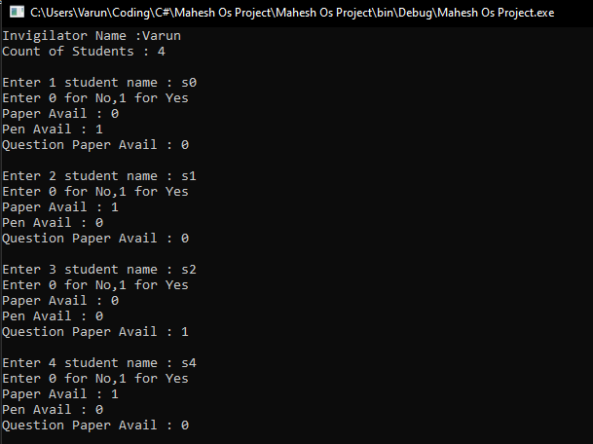

Items Placing on table by teacher
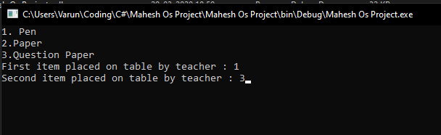

Final Output
